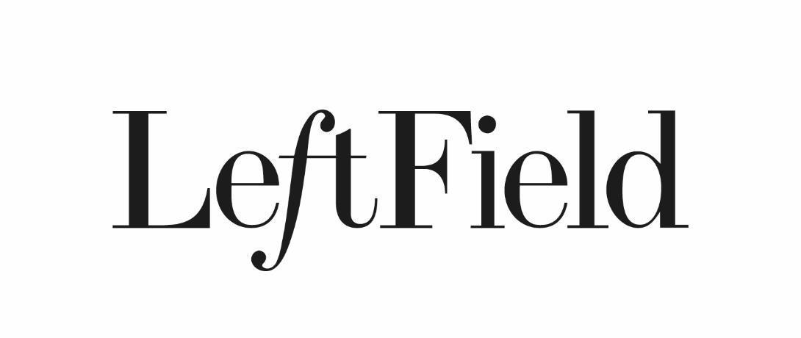
Organic Prosecco £7
Lind & Lime Gin & tonic £6

Chicken liver pate, homemade chutney, toasted sourdough £8
Skipness Hot Smoked salmon, cucumber & fennel £8
Crispy squid, sriracha mayo, lime £8
Tenderstem broccoli, honeyed almond, feta, red pesto £7
Pumpkin seed hummus, olive, toasted seeds, sourdough crisp £6.50
___

Chicken breast, roasted beets, crispy kale, buttery mash £16
6 hr cooked beef short rib, chunky chips, watercress, parmesan, truffle oil £17.9
Sea bass fillet, chickpea tagine, lime & coriander £1
Scottish Borders Ribeye steak, chips, peppercorn butter, green salad £25
Roasted cauliflower, tomato and spinach pearl barley risotto £14

LeftField Hot Seafood Platter: lobster, oysters, clams, mussels, squid £65 (24hr pre-order)
___

Dark chocolate mousse, caramelized baby figs, honeycomb £7.5
Boozy Affogato £7.5
Creme brulee, lemon shortbread £7
Ian Mellis cheese, spiced pickled pear, artisan biscuits £8.50

Please inform us of any allergies
Discretionary 10% service charge for tables of 6 and over

